Unit 301: Understand the fundamental principles and requirements of environmental technology systems

# Handout 2: Ground source heat pump

## Learning outcomes

The learner will:

1. Know the fundamental working principles of micro-renewable energy and water conservation technologies.
2. Know the fundamental requirements of building location/building features for the potential to install micro-renewable energy and water conservation systems to exist.
3. Know the fundamental regulatory requirements relating to micro-renewable energy and water conservation technologies.
4. Know the typical advantages and disadvantages associated with micro-renewable energy and water conservation technologies.

## Assessment criteria

The learner can:

* 1. Identify the fundamental working principles for each of the following heat producing micro-renewable energy technologies: ground source heat pump.

2.3 Clarify the fundamental requirements for the potential to install a ground source heat pump system to exist.

3.1 Confirm what would be typically classified as ‘permitted development’ under town and country planning regulations in relation to the deployment of the following technologies: ground source heat pump.

3.2 Confirm which sections of the current building regulations/building standards apply in

relation to the deployment of the following technologies: ground source heat pump.

4.1 Identify typical advantages associated with each of the following technologies: ground source heat pump.

4.2 Identify typical disadvantages associated with each of the following technologies: ground source heat pump.

## Ground source heat pump (GSHP)

Heat pumps make full use of heat naturally stored in the ground, water and even the air to reduce the amount of fossil fuels we need to burn to heat or cool our buildings.

The ground is continually soaking up and retaining warmth from the sun. Heat pumps extract that heat and use it to pre-heat water for space and water heating so reducing the amount of gas, oil or electricity consumed.

They work in the same way as a refrigerator, but on a larger scale. A refrigerator moves heat from its inside to its radiator at the back using a compressor. In the same way, a ground source heat pump moves heat from under the ground to a hot water supply. The ground source heat pump turns a *large* amount of *slightly hot* liquid into a *small* amount of *very hot* liquid.

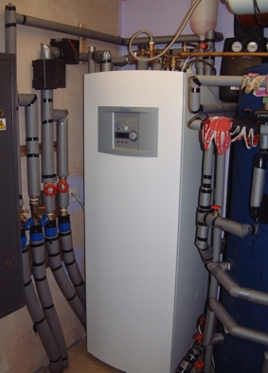This works in the summer as well as in the winter, 24 hours a day. As it is a low temperature heat source – unlike conventional central heating, which operates at high temperatures – larger heating surfaces such as under floor heating and low surface temperature radiators are the best way to extract maximum efficiency.

The higher the temperature of the heat source, the more efficiently the heat pump will operate, but the key thing is having a constant temperature. The earth around UK buildings is on average a constant 10°C, which is ideal.

The heat is collected by polyethylene pipes filled with a water and anti-freeze mixture that extract about 50 watts of heating energy per metre in a borehole or one kilowatt per 25 square metres with the horizontal coils. This temperature is ideal as a pre-heated source of water for heating or as a cool water source for cooling in summer.

## Installation location

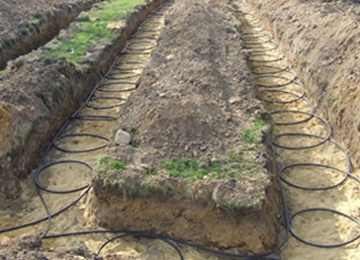The heat pump itself will go indoors, while the external pipes or coils, commonly called 'captors', can be laid horizontally or vertically depending on how much land space you have available to use. If the property has a large garden the captors can be laid horizontally. As a rule of thumb if the home has 100m2 of usable floor space then 150m2 of ground area will be needed to lay the captor(s) – a ratio of 1:1.5. Installation depth for horizontal captors varies from 300mm to 2 metres. These horizontal captors usually take the form of ‘slinky’ loops as shown right.

However, if the garden cannot meet this ratio the captors can be installed vertically and will only need 150mm diameter for each borehole (drill depth can vary between 32 and 180 metres and is dependent on the energy requirements of the premises).

## Planning requirements

Most householders can carry out small extensions or additions to their homes without the need for planning permission. This is known as ‘**permitted development**’.

Fitting a ground source heat pump in a house or a block of flats is classed as permitted development.

While planning permission is unlikely to be needed for excavations or drilling, provided the ground coil is installed under your own land, in sensitive areas such as Areas of Outstanding Natural Beauty (AONBs), planning permission may be required for the excavation works to lay the coils.

The Environment Agency should be consulted if an open loop system is planned, because water will be extracted, and returned to the ground, which will require licenses to abstract and re-inject the water.

## Building Regulations requirements

Heat pump heating systems for should meet the recommendations of the *Non‑domestic/Domestic Heating Compliance Guide* as a means of demonstrating compliance with the Building Regulations.

## Environmental protection

The environment agency publishes an *Environmental good practice guide for ground source heating and cooling* that gives detailed guidance on the proper procedures and materials that should be used when extracting heat from the ground.

## Legionella

*Approved Code of Practice and Guidance L8* includes hot water storage arrangements and requires that provisions are made to heat the whole water content of the calorifier, including that at the base, to a temperature of 60°C for one hour each day.

Only heat pump packages that are CE marked in compliance with the relevant European Directives may be offered for sale in the EU.

## Description: 04 underfloor heating.jpgAdvantages of ground source heat pump

* Quick capital recovery
* Reduced running costs
* Environmentally clean
* Renewable energy source
* Reduced CO2 emissions from the production of primary electrical energy (electricity can be obtained from renewable sources such as solar or hydro)
* Inversion-Cycle for summer cooling

## Disadvantages of ground source heat pumpDescription: 05 underfloor heating.jpg

* Ground source heat pumps are more expensive to install.
* Problems arise with ground source heat pumps if the installation is poorly designed or not matched to the heating needs of the building.

The design and installation of an effective ground source system depends on a thorough understanding of the movement of heat in the ground, the local geology and the heating and cooling requirements of your building.